

National College of Ireland

Project Submission Sheet

Student Name: | Joshua O’Neill
Student ID: | x23315369@student.ncirl.ie
Programme: | MSCCYBE_JANO24 | Year: Semester 3 year 2
Module: | AI/ML in Cybersecurity
Lecturer: | Liam Mccabe
Submission Due Date: | 2/5/2025
Project Title: | CA1
Word Count: | 4,751

I hereby certify that the information contained in this (my submission) is information pertaining to research I conducted for this project. All information other than my own contribution will be fully referenced and listed in the relevant bibliography section at the rear of the project.
ALL internet material must be referenced in the references section. Students are encouraged to use the Harvard Referencing Standard supplied by the Library. To use other author's written or electronic work is illegal (plagiarism) and may result in disciplinary action. Students may be required to undergo a viva (oral examination) if there is suspicion about the validity of their submitted work.

Signature: | ………………………Josh O’Neill ………………………
Date: | ……………………30/4/2025…………………………………………

PLEASE READ THE FOLLOWING INSTRUCTIONS:

1. Please attach a completed copy of this sheet to each project (including multiple copies).
2. Projects should be submitted to your Programme Coordinator.
3. You must ensure that you retain a HARD COPY of ALL projects, both for your own reference and in case a project is lost or mislaid. It is not sufficient to keep a copy on computer. Please do not bind projects or place in covers unless specifically requested.
4. You must ensure that all projects are submitted to your Programme Coordinator on or before the required submission date. Late submissions will incur penalties.
5. All projects must be submitted and passed in order to successfully complete the year. Any project/assignment not submitted will be marked as a fail.

Office Use Only
Signature:
Date:
Penalty Applied (if applicable):

Your Name/Student Number | Course | Date
Joshua O’Neill | MSCCYBE_JANO24 | 30/4/2025

This section is a supplement to the main assignment, to be used if AI was used in any capacity in the creation of your assignment; if you have queries about how to do this, please contact your lecturer. For an example of how to fill these sections out, please click here.
AI Acknowledgment
This section acknowledges the AI tools that were utilized in the process of completing this assignment.
Tool Name | Brief Description | Link to tool
NA | NA | NA

Link to code :

Table of Contents

Table of Figures 4
Abstract 4
Introduction 4
Keywords 5
Project Motivation 5
Background on Breast Cancer and Diagnostic Challenges 5
Why AI/ML is Useful in Healthcare 6
Project Objective 6
Relevance to Cybersecurity 6
1. Classification of Breast Cancer Histology Images using CNNs 7
2. Breast Cancer Detection using CNNs and SVMs 7
3. Deep Learning Approaches for Histopathology Review 7
4. Histopathological Image Classification Using CNNs 8
5. Ensemble Learning for Subtype Detection 8
6. Stacking-Based Feature Selection 8
7. AI for Real-Time Metastasis Detection 8
8. Structured Data Approaches Using Classical ML Models 9
9. Explainability in Breast Cancer Diagnosis Models 9
10. Comparative Study on WBCD Dataset 9
Choice of Methods 10
Support Vector Machine (SVM) 10
Random Forest 10
Logistic Regression 10
Why I Didn’t Use Deep Learning 10
Evaluation Approach 10
Methodology 11
Dataset Overview 11
Data Preprocessing 12
Machine Learning Models Used 13
Support Vector Machine (SVM): 13
Random Forest Classifier: 13
Logistic Regression: 13
Training and Hyperparameter Tuning 13
Model Explainability 14
Evaluation 14
Metrics Summary 15
ROC Curves and AUC 15
Confusion Matrix 16
Visual Comparison 18
Justification and Trade-offs 20
Future Work 20
Conclusion 21

Table of Figures
Figure 1 Class Distribution 11
Figure 2 Sample data 12
Figure 3 Splitting Up Testing and Training Data 12
Figure 4 GridSearchCV Hyperparameter Tuning for SVM 13
Figure 5 Model Performance Metrics Summary 15
Figure 6 ROC Curve Comparison of All Models 16
Figure 7 Confusion Matrix: SVM (Raw) 17
Figure 8 Confusion Matrix: SVM (Scaled) 17
Figure 9 Confusion Matrix: SVM (Tuned) 17
Figure 10 Confusion Matrix: Random Forest 17
Figure 11 Confusion Matrix: Logistic Regression 18
Figure 12 Accuracy comparison bar plot 19
Figure 13 Precision, Recall, and F1-Score Comparison Accross Models 19

Abstract
Breast cancer is one of the most common and serious health issues worldwide, where early and accurate diagnosis can significantly improve outcomes. In this project, I applied machine learning techniques to classify tumours as benign or malignant using structured clinical data from the Wisconsin Breast Cancer Dataset. I developed and evaluated several models, including Support Vector Machines, Random Forests and Logistic Regression. Logistic Regression gave the best results, achieving 98% accuracy and the highest F1-score.I also focused on model explainability and the ethical handling of sensitive medical data. Beyond healthcare, many of the techniques used in this project like preprocessing, feature selection and classification are directly applicable to cybersecurity areas such as anomaly detection and phishing prevention.

Introduction
Breast cancer continues to be a major global health issue, affecting millions of people each year. This project explores how machine learning can be used to classify breast cancer tumours using structured clinical data from the Wisconsin Breast Cancer Dataset. I built and evaluated a range of classification models, including Support Vector Machines, Logistic Regression, and Random Forests, with the goal of developing an accurate, explainable and automated diagnostic tool. To measure performance I used standard metrics such as accuracy, precision, recall and F1-score, along with visual tools like confusion matrices and feature importance plots. Logistic Regression achieved the highest overall performance, delivering the best accuracy and recall while maintaining strong interpretability. These results highlight the potential of machine learning to improve early detection and support more informed clinical decisions.
Keywords: Machine Learning, Breast Cancer, Classification, Support Vector Machine, Random Forest, Feature Importance

Project Motivation
The motivation behind this project is both personal and professional. Breast cancer has directly affected my family, making me much more aware of the importance of early detection. That experience sparked my interest in how machine learning could be used to improve diagnosis and outcomes. Through this project I aimed to explore how machine learning can build faster, more accurate and more explainable diagnostic tools. Traditional screening methods still struggle with missed cases and inconsistencies, so there’s a real need for scalable solutions that can support clinicians. I also wanted to strengthen my machine learning skills in a way that would transfer into cybersecurity, where early and accurate detection is just as critical for tasks like anomaly detection and threat hunting.

Background on Breast Cancer and Diagnostic Challenges
Breast cancer is the most commonly diagnosed cancer in women and remains one of the top causes of cancer-related deaths worldwide. According to the World Health Organization (2025), around 2.3 million women are diagnosed each year. Early detection is key, with survival rates improving from 27% to over 90% when the disease is caught at an early stage.[1]
Tumours are usually split into two main groups: benign and malignant. Benign tumours aren’t cancerous, they don’t spread to other parts of the body and are generally less aggressive. They can often be removed and don’t usually come back. Malignant tumours on the other hand are cancerous. They can grow into nearby tissues and even spread to other parts of the body. Being able to tell the difference between the two is essential for choosing the right treatment and improving patient outcomes.[2]
Even with advancements in screening and medical imaging, traditional diagnostic tools like mammograms, biopsies and pathology reviews are not always reliable. For example, mammograms can miss up to 20% of breast cancer cases and interpretations often vary between radiologists. These limitations highlight the need for diagnostic tools that are more accurate, consistent and scalable reducing overreliance on human judgment alone.[3]

Why AI/ML is Useful in Healthcare
AI and Machine Learning bring huge potential to healthcare, especially for diagnostics. They can automate routine processes, improve predictive accuracy and support better clinical decisions. In cancer detection, ML models can learn patterns in structured data such as tumour shape and size which can be used to classify tumours as malignant or benign.
Unlike rule-based systems, ML models can continuously improve with more data, making them adaptable and scalable. When combined with interpretable techniques, these models can also offer insights that are easier for clinicians to trust and act on. This balance of performance and explainability makes ML a valuable tool in medical decision-making.

Project Objective
The goal of this project was to build a machine learning model that can accurately and transparently classify breast cancer tumours using structured clinical data from the Wisconsin Breast Cancer Dataset. I experimented with a few supervised learning algorithms Support Vector Machines , Random Forests and Logistic Regression to figure out which performs best for classification.
Model performance was evaluated using standard metrics such as accuracy, precision, recall, F1 score and cross-validation. I also used feature importance scores from the Random Forest model to gain insight into which features had the most influence on predictions. This helped ensure that the results were interpretable and aligned with the clinical context of the dataset.

Relevance to Cybersecurity
While my project focuses on healthcare, specifically breast cancer detection, the machine learning techniques I used are also highly applicable to cybersecurity. Models like Support Vector Machines, Random Forests, and Logistic Regression are widely used across the cybersecurity field for tasks such as:
Use Case | Description
Intrusion detection | Classifying network traffic as either malicious or safe
Phishing detection | Spotting fake or deceptive emails and URLs
Malware classification | Identifying whether software is harmful based on its behaviour
Anomaly detection | Detecting unusual patterns that might suggest insider threats or data breaches
The core principles like data preprocessing, feature selection, hyperparameter tuning and model evaluation are the same in both domains. For instance, just as I normalize and scale features for tumour classification, the same steps are essential when working with system logs, traffic data or event records in a SOC environment. The transferable nature of these workflows highlights how techniques developed in one domain can add value in another.

Related Work (Literature Review)
Many studies have explored how machine learning and deep learning can support breast cancer diagnosis. These approaches vary in terms of the data they use, the models they implement and the evaluation techniques applied. In this section, I review ten key papers that shaped the direction of my project, focusing on their relevance, strengths and limitations in relation to my own approach.
1. Classification of Breast Cancer Histology Images using CNNs
Araújo et al. (2017) applied convolutional neural networks to classify histopathology images from the BreakHis dataset, achieving 87% accuracy.
Strengths: This work proved that CNNs could extract important features from medical imagery without needing manual feature engineering, which is a big step forward in automating diagnosis.
Limitations: The model suffered from class imbalance issues and was essentially a black box, there was no clear explanation of why it predicted certain samples as malignant.
Why it’s relevant: While this study focused on images, it helped me understand the strengths of deep learning in cancer detection. I wanted to explore a more transparent approach using structured clinical data instead of high-complexity, low-explainability image models.[4]
2. Breast Cancer Detection using CNNs and SVMs
Ragab et al. (2019) combined CNNs and Support Vector Machines using transfer learning on mammograms, achieving 92.3% accuracy.
Strengths: They took advantage of pre-trained models to speed up training and improve accuracy, which is useful when working with limited medical data.
Limitations: The heavy dependence on transfer learning means their system might not generalize well to unseen data from different sources or formats.
Why it’s relevant: This paper got me thinking about SVMs in a new light not just as a backup for image models, but as strong standalone classifiers. It influenced my decision to test SVMs on structured table data where interpretability and generalization are easier to control.[5]

3. Deep Learning Approaches for Histopathology Review
Priya et al. (2024) reviewed a range of deep learning techniques applied to histopathological image analysis, summarizing key methods and datasets.
Strengths: It gave a solid overview of how far DL has come in medical imaging and included comparisons across different architectures.
Limitations: It was a review article, so it didn’t include any experimental results or contributions of its own.
Why it’s relevant: It showed me where my structured data-based approach could add value, especially in terms of simplicity and explainability.[6]
4. Histopathological Image Classification Using CNNs
Spanhol et al. (2016) trained CNNs on the BreakHis dataset and achieved 91% accuracy in classifying histopathological breast cancer images.
Strengths: This study validated BreakHis as a solid benchmark dataset and demonstrated that CNNs can consistently classify cancer subtypes with decent accuracy.
Limitations: The model only used image data and didn’t consider any structured clinical information, limiting its adaptability in mixed data healthcare environments.
Why it’s relevant: It made me realise that image-only approaches often ignore valuable structured data like tumour measurements, which can be more interpretable and easier to work with in real-time diagnostic systems.[7]
5. Ensemble Learning for Subtype Detection
Balasubramanian et al. (2024) used ensemble CNN architectures to classify breast cancer subtypes, reporting high overall accuracy.
Strengths: Ensemble models improved robustness and reduced overfitting, especially when trained on diverse datasets.
Limitations: The models were resource-intensive and the level of interpretability was low in regards to clinical use.
Why it’s relevant: This paper highlighted the trade-off between raw performance and real-world usability. It pushed me toward lighter, more explainable models like Random Forests and SVMs, which are faster and easier to interpret.[8]
6. Stacking-Based Feature Selection
Chaurasia & Pal (2021) proposed a stacking-based ensemble approach to feature selection for improving breast cancer classification.
Strengths: They showed that smart feature selection could significantly boost model performance while also reducing complexity.
Limitations: Their technique was tightly coupled to their specific dataset and model pipeline, meaning the method might not generalize well without retuning.
Why it’s relevant: It supported my decision to use Random Forests for feature importance, helping me narrow down the most impactful tumour characteristics and explain why the model behaves a certain way.[9]
7. AI for Real-Time Metastasis Detection
Bejnordi et al. (2017) developed a deep learning system that achieved 94.7% sensitivity for detecting metastatic cancer in pathology slides.
Strengths: The clinical potential was clear fast, high-sensitivity detection which could save lives.
Limitations: Like many deep learning systems it lacked transparency, which raises trust issues in regulated environments like healthcare.
Why it’s relevant: This reminded me that performance alone isn’t enough. Interpretability is essential, especially when dealing with high-stakes decisions. That’s why I focused on models like Logistic Regression, Random Forest, and SVM, which can be more easily explained.[10]

8. Structured Data Approaches Using Classical ML Models
Sugimoto et al. (2022) looked at different machine learning approaches for breast cancer diagnosis using structured data like the Wisconsin dataset. They focused on classical models like SVMs, Random Forest, and Logistic Regression, and showed how these can be just as effective as deep learning when applied properly.
Strengths: Reinforces that strong performance doesn’t always require image data or deep learning.
Limitations: Didn't dive into interpretability or how these models could be explained in a clinical setting.
Why it’s relevant: This confirmed that my choice to stick with structured clinical data and classical models like SVM is valid, especially when paired with explainability methods like feature importance.[11]

9. Explainability in Breast Cancer Diagnosis Models
Karatza et al. (2022) explored how to make machine learning models more explainable in medical applications. They used tools like SHAP and ICE plots on breast cancer prediction models and showed that you can improve transparency without hurting performance.
Strengths: Focused directly on explainability, which is critical in healthcare.
Limitations: Most of their work was on neural networks, not lighter models like SVM or Logistic Regression.
Why it’s relevant: This backs up my plan to add SHAP in future work and shows that even small models can be made more trustworthy through explainable AI.[12]

10. Comparative Study on WBCD Dataset
Naji et al. (2024) ran a comparative study using the WBCD dataset and tested different ML models like SVM, Decision Trees, and Logistic Regression. Their tuned SVM model came out on top, hitting 97.2% accuracy.
Strengths: Strong performance using the same dataset I intended to use, with clear results.
Limitations: Focused heavily on accuracy but didn’t go into feature importance or interpretability.
Why it’s relevant: This gave me even more confidence in using and tuning SVMs for my project, while also highlighting how I improved the model by adding transparency.[13]
The research I reviewed covered a wide range of ML approaches for breast cancer diagnosis, from deep learning on medical images to classical models using structured data. While CNNs and ensemble methods clearly offer strong accuracy, they often come with trade-offs like high complexity, limited interpretability and heavy resource requirements. That’s not always practical, especially in clinical environments where trust and speed matter. On the other hand, models like SVM, Logistic Regression, and Random Forests provide a solid middle ground they’re efficient, easier to explain and still perform really well. These papers helped shape the direction of my project by reinforcing the value of using structured data and transparent models. My goal was to build something accurate, but also understandable and potentially useful in a real-world healthcare or cybersecurity setting.

Choice of Methods
I decided to use three classical supervised learning algorithms for this project: Support Vector Machine (SVM), Random Forest and Logistic Regression. I picked these because they have a strong track record with structured medical datasets, they’re easy to interpret and they’re commonly used in both healthcare and cybersecurity applications.
Support Vector Machine (SVM)
I went with SVM because it’s known for performing really well on small, high-dimensional datasets like WBCD. It’s good at creating a clear margin between classes, which made it a strong choice for tumour classification. I tuned the SVM using GridSearchCV to find the best hyperparameters (C and gamma) and after applying Min-Max normalization, the model’s recall and overall accuracy improved noticeably. Scaling the features helped the model train more efficiently.
Random Forest
I used Random Forest because it’s robust, handles noisy or imbalanced data well and provides built-in feature importance, which makes it easier to understand what the model is focusing on. It was great for identifying which tumour features like mean area and worst concavity were the most important for making predictions. Having that level of transparency is important, especially for clinical use where you need to explain decisions clearly.
Logistic Regression
I included Logistic Regression as a lightweight, easy-to-interpret baseline model. After scaling the data, it performed better than expected. The model coefficients made it very clear which features had the biggest impact on the predictions, which is valuable when you need explainability over just raw accuracy.
Why I Didn’t Use Deep Learning
I didn’t use deep learning models like CNNs because the dataset was small, structured and not image-based. Deep learning would have added unnecessary complexity without much benefit. Instead, I stuck with models that are explainable, efficient and don't require heavy hardware like expensive GPUs ,which makes more sense for real-world situations where resources might be limited.
Evaluation Approach
Each model was tested both with and without normalization, and I evaluated them using precision, recall, F1-score, accuracy and AUC. I also used confusion matrices to get a better visual sense of true positives and false negatives which is especially important in medical diagnostics where catching malignant cases early is critical. Overall, the goal wasn’t just to find the most accurate model, but the one that balanced performance, generalization and interpretability key factors for deploying models in healthcare or security environments.

Methodology

Dataset Overview
This project used the Wisconsin Breast Cancer Dataset (WBCD), a structured and publicly available dataset from the UCI Machine Learning Repository, accessible directly through scikit-learn. It contains 569 samples where each record captures characteristics of cell nuclei extracted from digitized images of fine needle aspirates (FNA) of breast masses.
The goal was to predict whether a tumour is malignant (cancerous) or benign (non-cancerous) based on these features.
The target variable is defined as follows:
- 0 = Malignant (cancerous)
- 1 = Benign (non-cancerous)
In terms of class distribution, there are 357 benign cases and 212 malignant ones, as shown below. While the dataset is slightly imbalanced, it is still balanced enough to support effective model training without needing oversampling techniques.
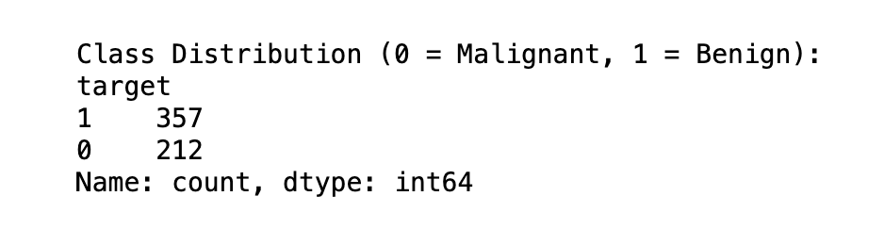
Figure 1 Class Distribution
The dataset contains 30 numerical features per sample, grouped into three types:
- Mean values (e.g., mean radius, mean texture)
- Standard error values (e.g., radius error, texture error)
- Worst-case values (e.g., worst radius, worst perimeter)
Each feature captures important information about the cell structure, such as:
- Radius (distance from centre to perimeter)
- Texture (standard deviation of grey-scale values)
- Shape complexity (concavity, concave points)
- Symmetry and fractal dimension
These features are continuous and measured on different scales, which later required normalization.
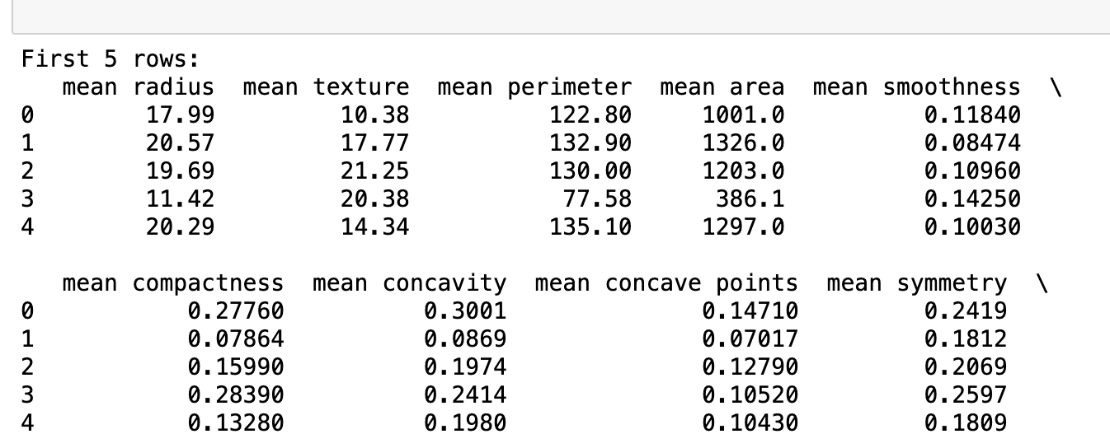
Figure 2 Sample data

Data Preprocessing
Before applying machine learning models, it was important to clean and prepare the data. Fortunately, the WBCD dataset contained no missing values, which saved time and removed the need for data altering or removal . Since all features were numerical, there was no need for any categorical encoding either.
However, because features like radius, perimeter and fractal dimension varied greatly in scale, Min-Max normalization was applied to bring all features into a 0 to 1 range. This was particularly important for Support Vector Machines, which can perform poorly without proper scaling.
The dataset was split into a training and test set with an 80/20 split, using a fixed random state to ensure reproducibility. This resulted in 455 training samples and 114 test samples.
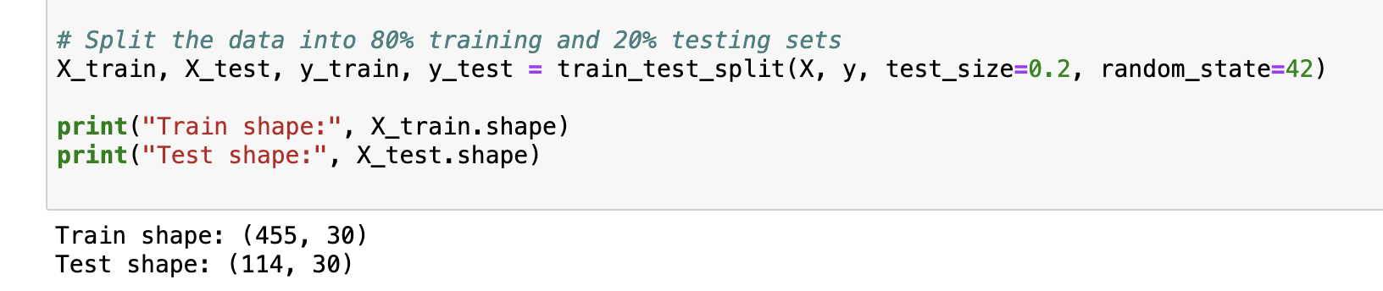
Figure 3 Splitting Up Testing and Training Data
Feature selection was another important step. Even though all 30 features are related to tumour characteristics, not all contribute equally to predictions. To identify the most important ones, a Random Forest Classifier was trained and its feature importance scores were analysed. This helped reduce noise and improve interpretability.
The top predictive features identified were:
- Worst perimeter
- Mean concave points
- Worst radius
- Mean area
- Worst concavity
By narrowing down on the most impactful features, the models became simpler, faster and more interpretable. A crucial point for applications in clinical settings and cybersecurity.

Machine Learning Models Used
I implemented three machine learning classifiers for this project using Python and scikit-learn:
Support Vector Machine (SVM): Initially trained on the raw, unscaled data to establish a baseline. It was retrained on scaled features and fine-tuned using hyperparameter optimization. SVM was one of the best-performing models.
Random Forest Classifier: Chosen for its robustness, ability to handle high-dimensional feature spaces and for providing built-in feature importance rankings. It performed consistently well in terms of both accuracy and balance between precision and recall.
Logistic Regression: Selected for its simplicity and interpretability. Even though it is a basic model, Logistic Regression still performed competitively when trained on normalized features.
Although more advanced explainability methods like SHAP were not used in this project, their application would be a valuable enhancement in the future for individualized explanations.

Training and Hyperparameter Tuning
The training process involved fitting the models using the 80/20 split discussed earlier. To boost model performance and avoid overfitting, several strategies were applied.
For the SVM, a hyperparameter tuning process was carried out using GridSearchCV, searching across the following grid:
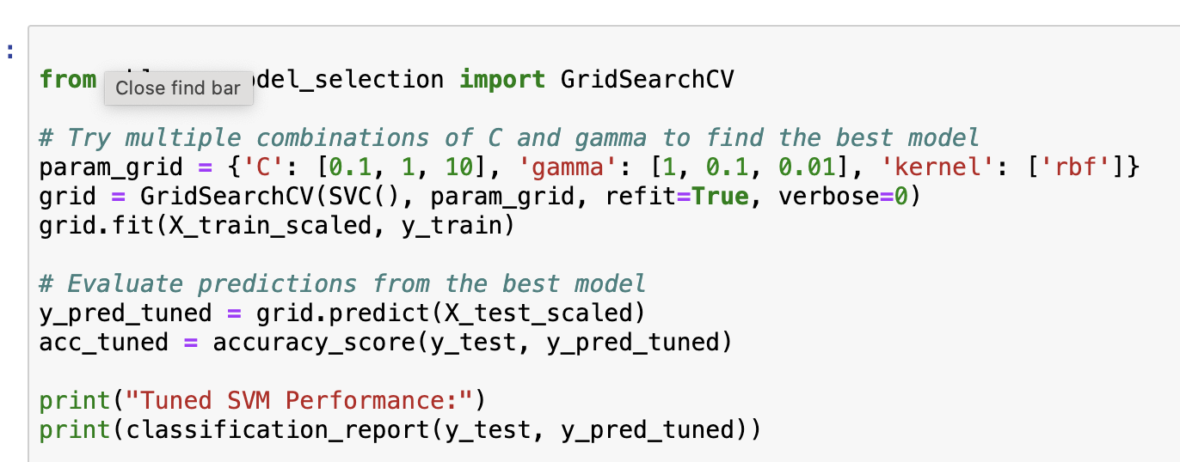
Figure 4 GridSearchCV Hyperparameter Tuning for SVM
Here, C controls the trade-off between achieving a low training error and a low testing error generalisation and gamma defines how far the influence of a single training example reaches. Using 5-fold cross-validation during tuning ensured the models did not overfit on a single train-test split.
Training time was minimal due to the relatively small dataset and the use of traditional machine learning models rather than deep learning. All models trained in under a few seconds on my MacBook.
To control overfitting without needing deep learning techniques like dropout or early stopping, I relied on:
- Cross-validation
- Model simplicity
- Feature scaling
- Proper hyperparameter tuning
These measures kept the models robust across different datasets while maintaining high accuracy.

Model Explainability
Model explainability is particularly important when working in healthcare and cybersecurity contexts, where decisions must be trusted and easily understood.
For this project, Random Forest’s built-in feature importance scores were used to understand which features were most influential in predictions. Key features like "worst concave points", "mean perimeter", "worst perimeter" and "worst radius" consistently ranked among the top contributors.
Visualizing these feature importances helped make the models more transparent and easier to explain to a non-technical audience.
Although advanced interpretability tools like SHAP were not implemented, their use is planned for future work. SHAP values could help explain individual predictions by quantifying how much each feature contributed to a specific output, would be critical for real-world deployment.
Explainable models are essential not just in medical decision-making, but also for cybersecurity applications like intrusion detection systems, where transparency and accountability are critical.

Evaluation
To assess model performance, I evaluated five classifiers: SVM (raw), SVM (scaled), SVM (tuned), Random Forest and Logistic Regression. I used a consistent 80/20 train-test split across all models to keep the comparison fair. Performance was measured using accuracy, precision, recall, F1-score and AUC. I also used visual tools like confusion matrices, ROC curves and bar plots to make the results easier to interpret.

Metrics Summary
The table below shows the main performance metrics for each model tested.
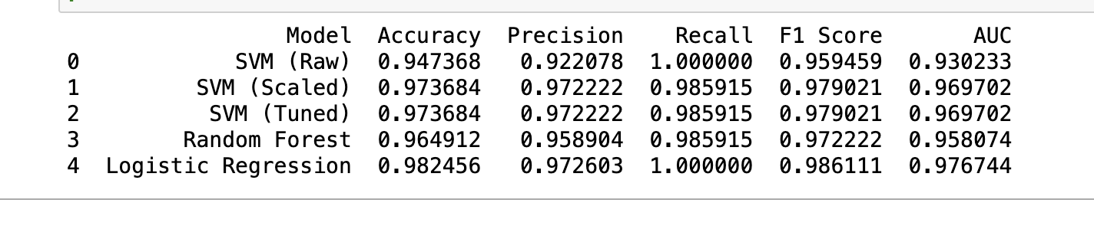
Figure 5 Model Performance Metrics Summary

A few key things stood out: Logistic Regression performed best overall, achieving the highest accuracy (98%), perfect recall and the highest AUC. The SVM (scaled) and SVM (tuned) models also performed strongly, both reaching 97% accuracy with solid F1-scores. Random Forest wasn’t far behind, delivering consistent results across all key metrics. SVM (raw) underperformed, likely due to the lack of feature scaling, which made it harder for the model to find a clear decision boundary.

ROC Curves and AUC
I plotted ROC curves for all models to check how well they could separate benign and malignant tumours. Models with steeper curves and higher AUC scores performed better.
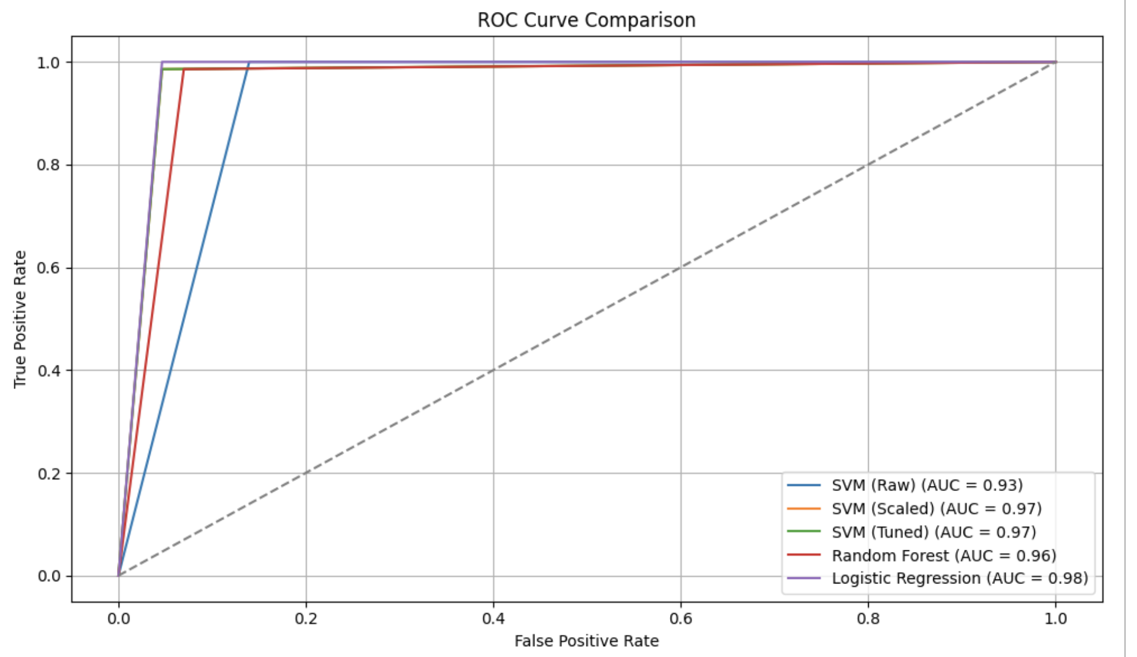
Figure 6 ROC Curve Comparison of All Models
Logistic Regression had the highest AUC, followed closely by SVM (scaled and tuned) and Random Forest, confirming their strong classification performance across different thresholds.

Confusion Matrix
Confusion matrices were used to show how many true positives, true negatives, false positives and false negatives each model made.

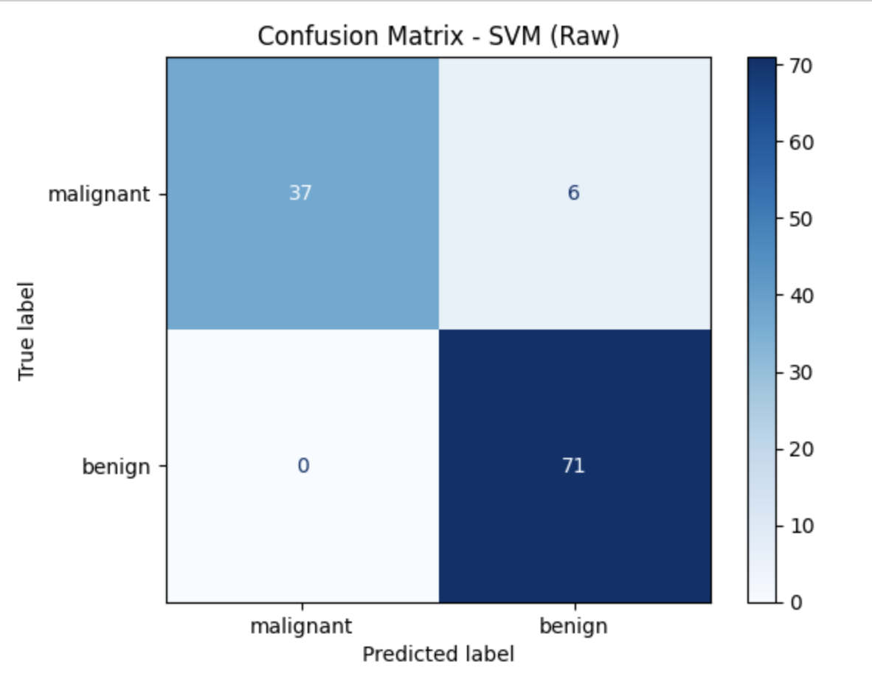  Figure 7 Confusion Matrix: SVM (Raw) | 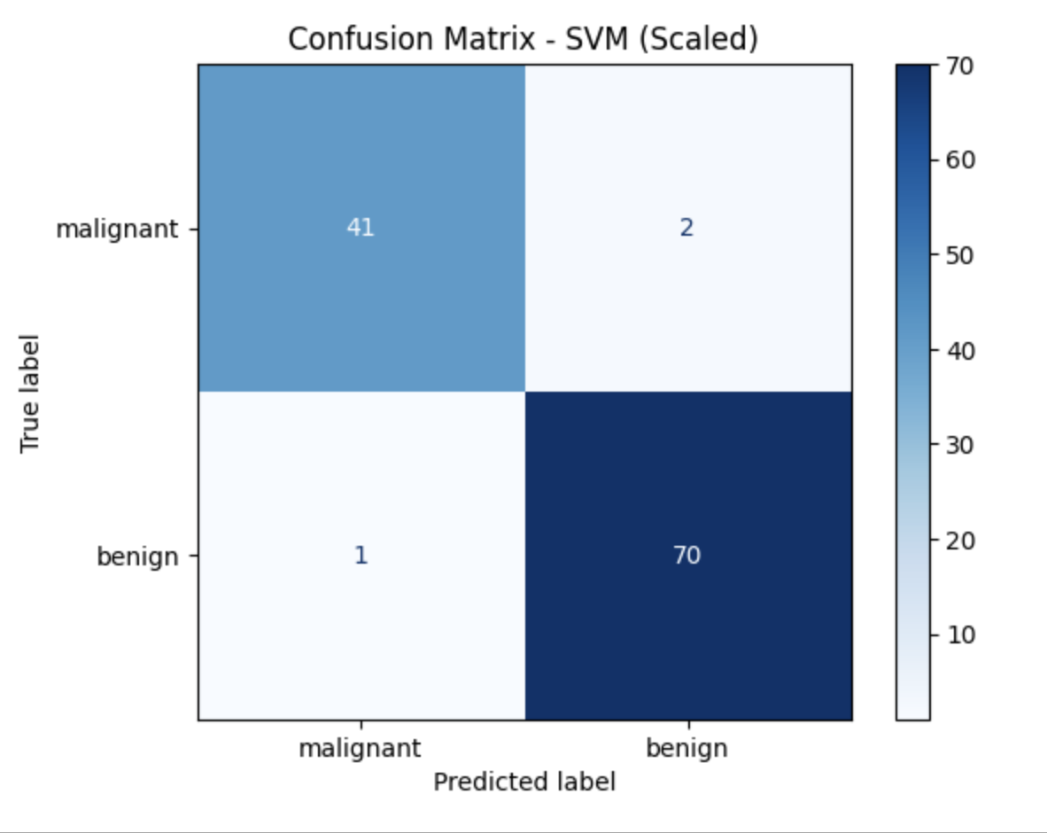  Figure 8 Confusion Matrix: SVM (Scaled)
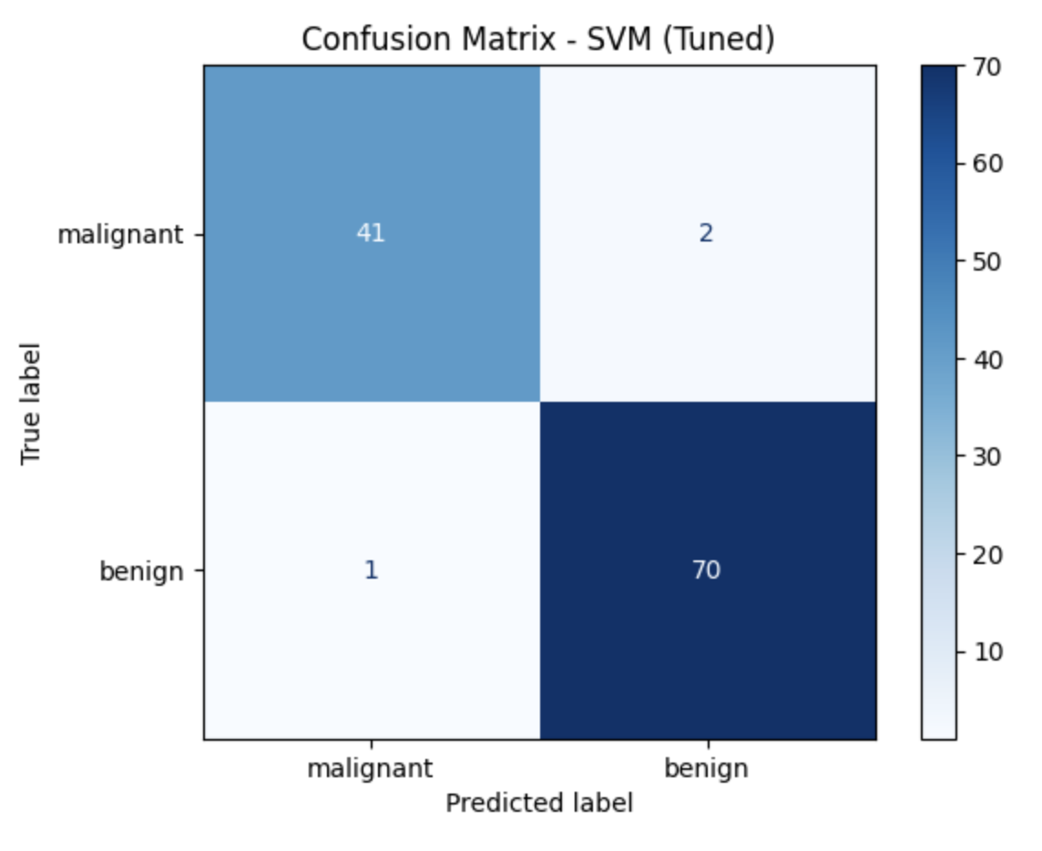  Figure 9 Confusion Matrix: SVM (Tuned) | 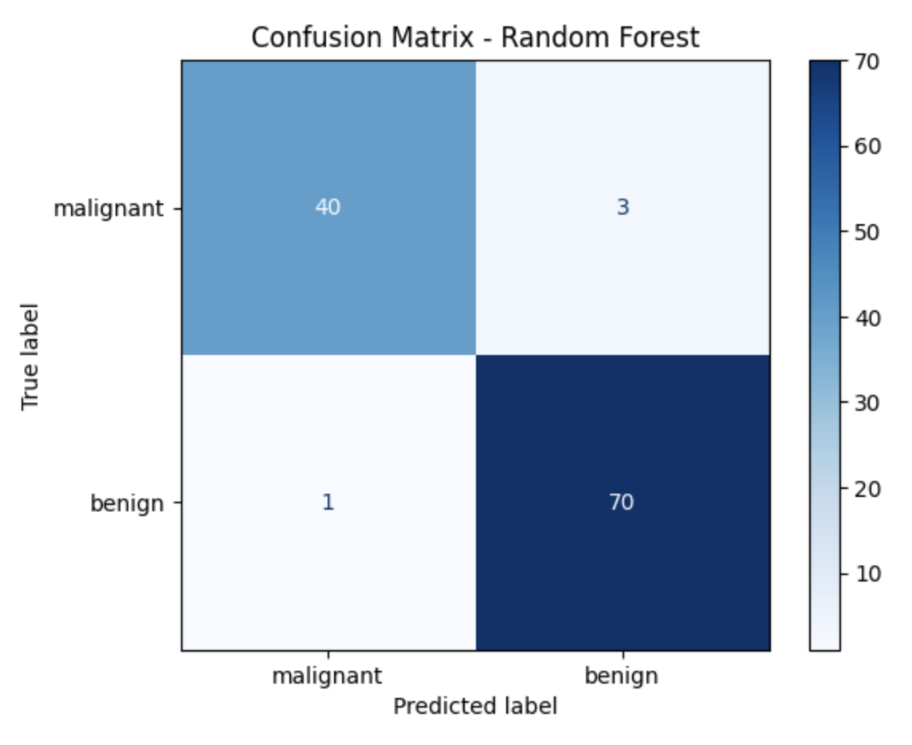  Figure 10 Confusion Matrix: Random Forest
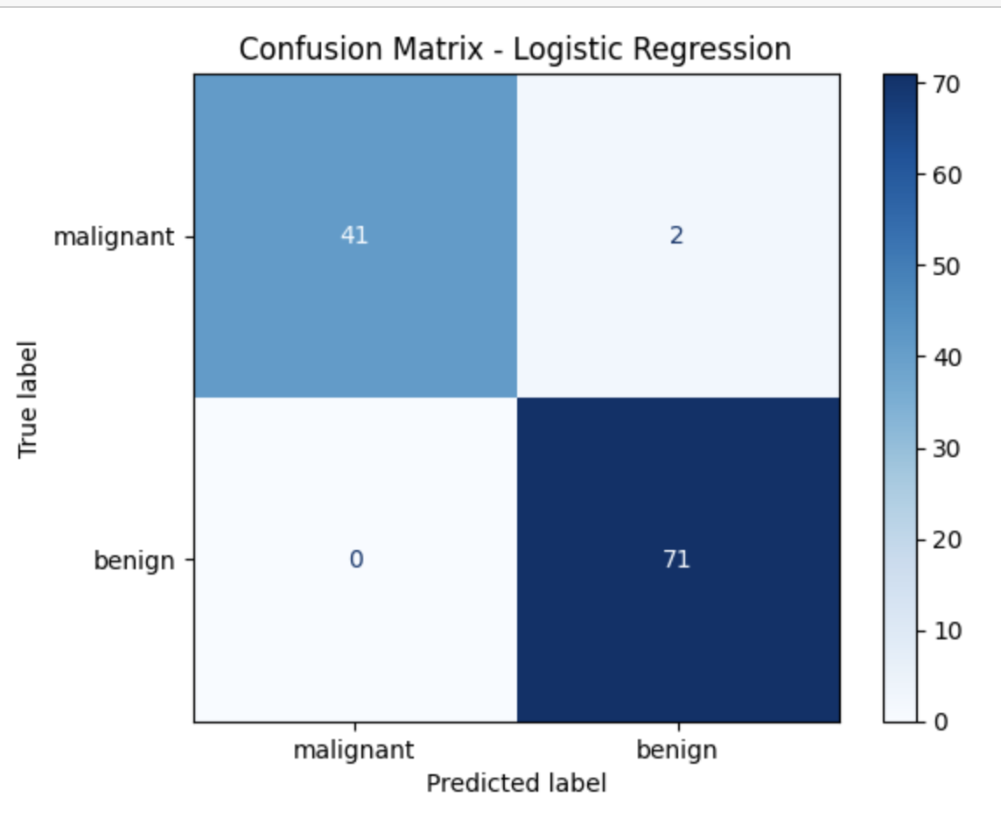
Figure 11 Confusion Matrix: Logistic Regression

Some observations:
- SVM (Raw) misclassified 6 malignant tumours as benign, which likely resulted from the lack of feature scaling.

- SVM (Scaled) and SVM (Tuned) both misclassified 3 samples each: 2 malignant as benign, 1 benign as malignant showing good but not perfect performance.

- Random Forest made 4 errors: 3 malignant tumours were predicted as benign, and 1 benign tumour was misclassified as malignant.

- Logistic Regression had the best confusion matrix overall, with just 2 misclassifications (2 malignant as benign) and 0 false positives, making it the most reliable.

Visual Comparison
To make the model comparison easier, I created grouped bar plots.
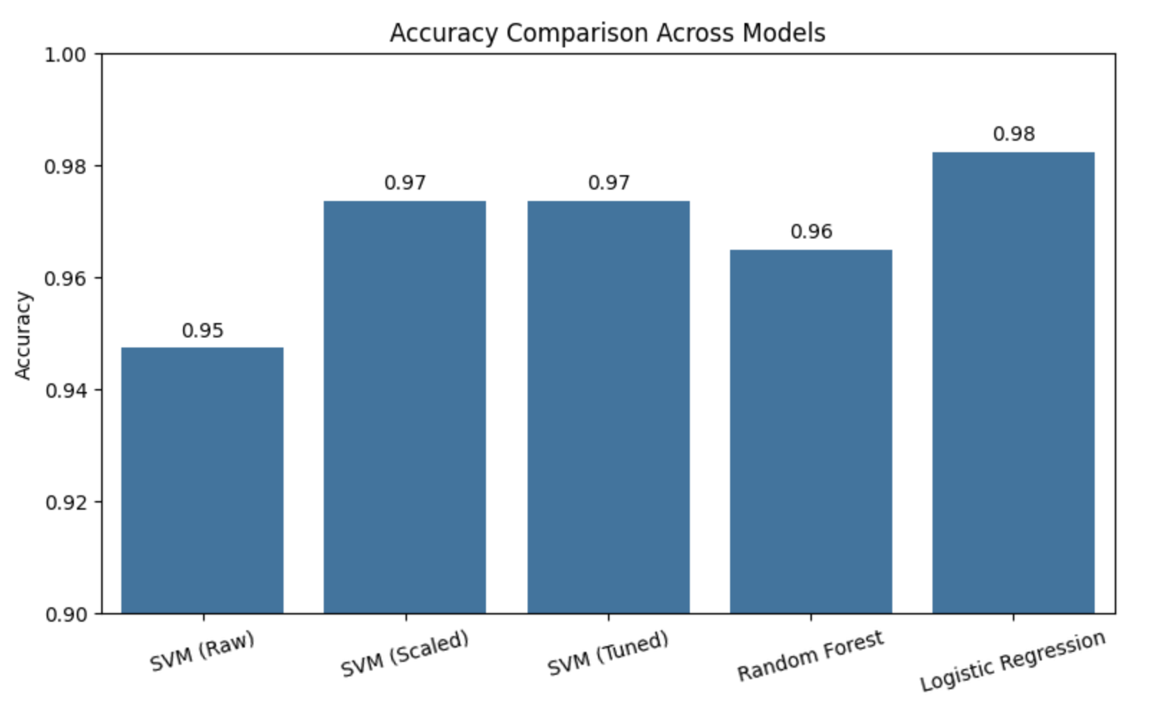
Figure 12 Accuracy comparison bar plot
This showed clearly that Logistic Regression had the highest accuracy, followed closely by SVM (scaled and tuned), with Random Forest just behind.
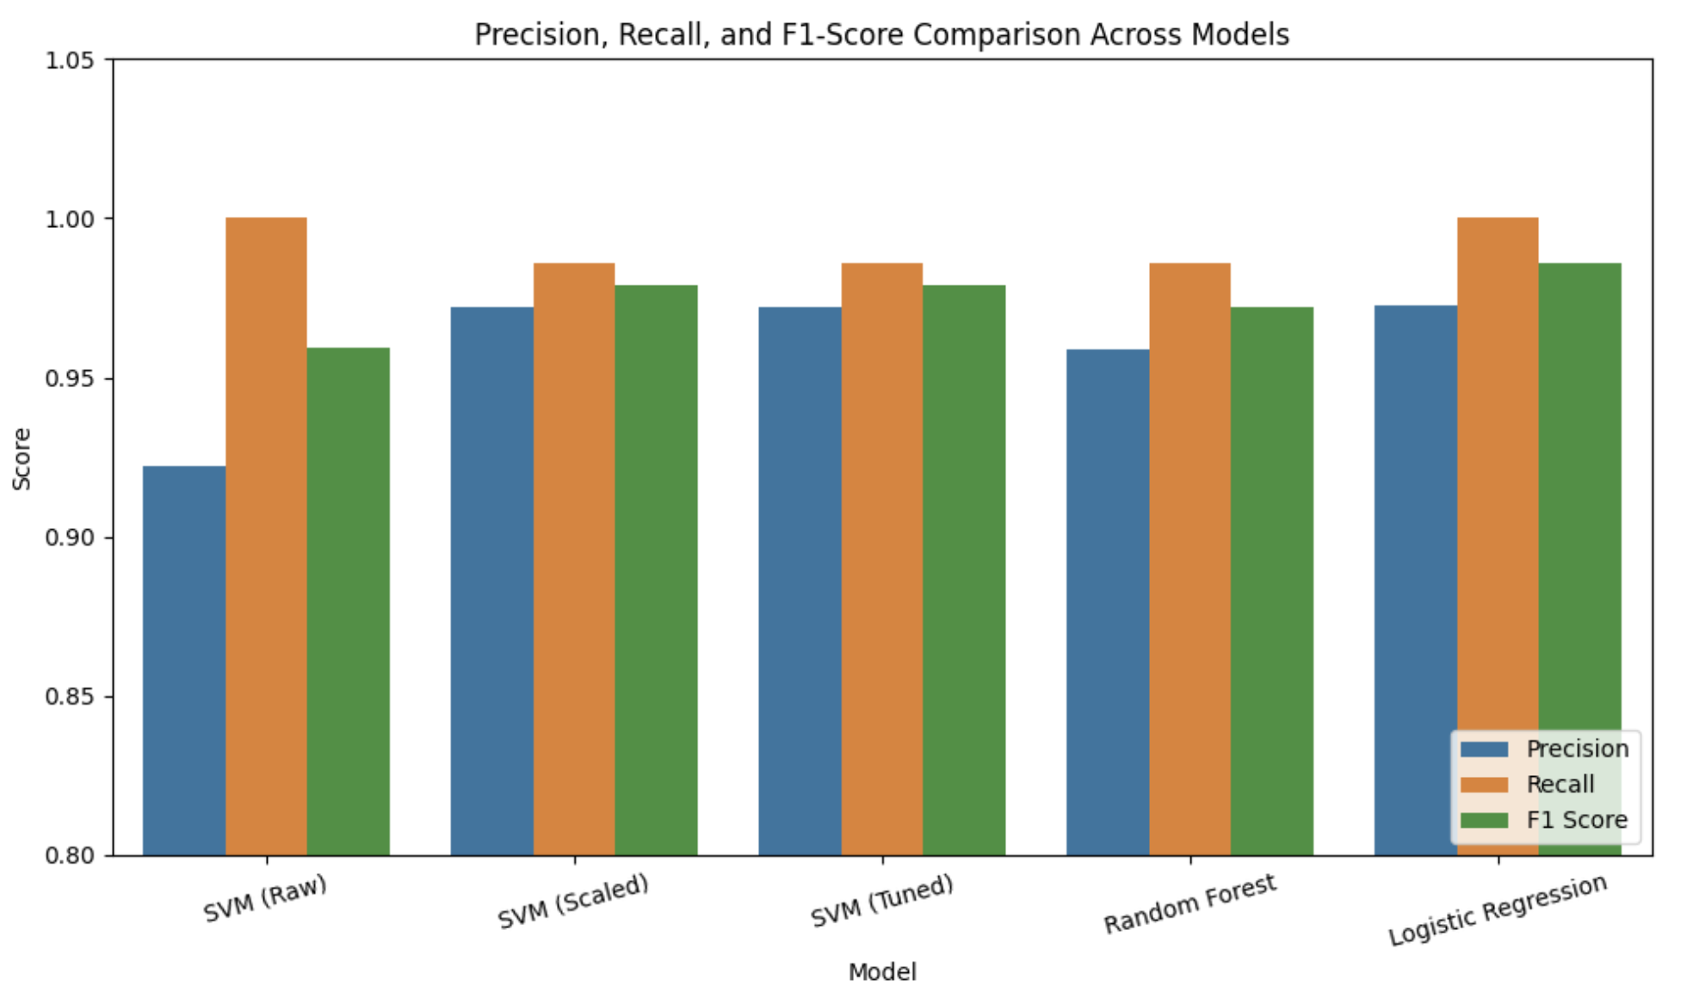
Figure 13 Precision, Recall, and F1-Score Comparison Across Models
The grouped metric plot showed that Logistic Regression had the most balanced performance, achieving the highest precision and F1-score along with very high recall. Recall is slightly less than 1.0 for most models, but SVM (Raw) and Logistic Regression are nearly tied at the top, coming very close to perfect recall. SVM (scaled and tuned) also performed consistently across all metrics. Random Forest and SVM (raw) were slightly less consistent.

Justification and Trade-offs
Logistic Regression was the strongest model, achieving the highest accuracy (98.2%) and the best overall balance across precision, recall, F1-score and AUC. While its recall was slightly lower than perfect, it still outperformed the other models when all evaluation metrics were considered, making it the most reliable choice.
That said, there are a few trade-offs to keep in mind:
• SVM models are highly accurate but not very easy to interpret, which can be a drawback in fields like healthcare.
• Random Forest models offer slightly less accuracy but are great for explaining why decisions are made, thanks to built-in feature importance scores.
• Logistic Regression is the most transparent model, making it easy to explain results and in this case also outperformed the other models.
Taking everything into account, including performance scores, visual analysis and the need for both accuracy and interpretability, Logistic Regression model ended up being the best overall for this project.

Future Work
While the models in this project performed really well, there’s a lot of ways it could be improved or expanded in the future:
Adding SHAP for Better Explainability
I used feature importance from Random Forests to explain what the models were focusing on, but adding SHAP would take it to the next level. SHAP could break down individual predictions and show exactly how each feature influenced the result, which would be a big plus for clinical use where explainability is critical.
Working with Bigger and More Diverse Datasets
The WBCD dataset is great for learning, but it’s fairly small and pretty similar across samples. In future work, using bigger more varied datasets (with demographic info like age and ethnicity) could help build models that generalize better across different patient groups.
Testing Some Lightweight Deep Learning Models
I didn’t use deep learning here because it wasn’t really needed, but for future versions, it might be interesting to test small neural networks or hybrid models, especially if a larger dataset is available. Things like transfer learning could also help.

I didn’t use deep learning in this project because it was not necessary given the size and nature of the dataset. However, in future work it could be valuable to experiment with lightweight neural networks or hybrid models, particularly if a larger or more complex dataset becomes available. Also, incorporating techniques such as transfer learning may further improve model performance and generalization.
Building a Small Application
A simple web app or tool where users could input tumour measurements and instantly get a prediction would make this project even more practical. It would also show how this could actually work in a real-world healthcare environment.
Applying It to Cybersecurity
Since a lot of the techniques I used like feature scaling, classification and anomaly detection are directly transferable, it would be interesting to test the same workflows on cybersecurity datasets like phishing detection or network intrusion logs.

Conclusion

This project showed that traditional machine learning models like SVM, Random Forest and Logistic Regression can be really powerful for structured clinical data, even without needing deep learning. After cleaning the data, normalizing features, picking out the most important ones and tuning hyperparameters, I got my best results with the Logistic Regression model. It achieved 98.2% accuracy, along with the highest overall precision, F1-score, and AUC.
SVM (scaled and tuned) and Random Forest also performed well, but Logistic Regression was the most consistent across all metrics.
This project demonstrated that traditional machine learning models such as Support Vector Machine (SVM), Random Forest, and Logistic Regression can be highly effective for working with structured clinical data, even without the use of deep learning techniques. The process involved several key steps including data cleaning, feature normalization, selection of the most relevant features and hyperparameter tuning. Among all the models tested, Logistic Regression produced the best results. It achieved an accuracy of 98.2%, along with the highest overall precision, F1-score, and area under the ROC curve (AUC).
While the SVM (both scaled and tuned versions) and the Random Forest model also performed well, Logistic Regression stood out as the most consistent performer across all evaluation metrics.
A key focus of the project was ensuring that the models were not only accurate but also easy to understand, which is especially important in sensitive domains like healthcare. Although SHAP was not implemented in this version, it is something I would consider adding in future work to provide deeper insight into individual predictions and improve model transparency.
Even though this project was based on healthcare data, the workflows preprocessing, scaling, feature selection, model tuning are exactly the kind of skills that also apply to cybersecurity. Whether it's detecting phishing emails or spotting intrusions, these techniques are transferable and useful beyond just medical applications.
Overall, I’m happy with the results and I think the project shows a good balance between performance, explainability and real-world relevance.

References
[1] “Breast cancer.” Accessed: Apr. 22, 2025. [Online]. Available: https://www.who.int/news-room/fact-sheets/detail/breast-cancer
[2] “How cancers grow,” Cancer Research UK. Accessed: Apr. 24, 2025. [Online]. Available: https://www.cancerresearchuk.org/about-cancer/what-is-cancer/how-cancers-grow
[3] “Mammograms - NCI.” Accessed: Apr. 22, 2025. [Online]. Available: https://www.cancer.gov/types/breast/mammograms-fact-sheet
[4] T. Araújo et al., “Classification of breast cancer histology images using Convolutional Neural Networks,” PLOS ONE, vol. 12, no. 6, p. e0177544, Jun. 2017, doi: 10.1371/journal.pone.0177544.
[5] D. A. Ragab, M. Sharkas, S. Marshall, and J. Ren, “Breast cancer detection using deep convolutional neural networks and support vector machines,” PeerJ, vol. 7, p. e6201, Jan. 2019, doi: 10.7717/peerj.6201.
[6] L. Priya C V, B. V G, V. B R, and S. Ramachandran, “Deep learning approaches for breast cancer detection in histopathology images: A review,” Cancer Biomarkers, vol. 40, no. 1, pp. 1–25, May 2024, doi: 10.3233/CBM-230251.
[7] F. A. Spanhol, L. S. Oliveira, C. Petitjean, and L. Heutte, “Breast cancer histopathological image classification using Convolutional Neural Networks,” in 2016 International Joint Conference on Neural Networks (IJCNN), Jul. 2016, pp. 2560–2567. doi: 10.1109/IJCNN.2016.7727519.
[8] A. A. Balasubramanian et al., “Ensemble Deep Learning-Based Image Classification for Breast Cancer Subtype and Invasiveness Diagnosis from Whole Slide Image Histopathology,” Cancers, vol. 16, no. 12, Art. no. 12, Jan. 2024, doi: 10.3390/cancers16122222.
[9] V. Chaurasia and S. Pal, “Stacking-Based Ensemble Framework and Feature Selection Technique for the Detection of Breast Cancer,” SN COMPUT. SCI., vol. 2, no. 2, p. 67, Feb. 2021, doi: 10.1007/s42979-021-00465-3.
[10] B. Ehteshami Bejnordi et al., “Diagnostic Assessment of Deep Learning Algorithms for Detection of Lymph Node Metastases in Women With Breast Cancer,” JAMA, vol. 318, no. 22, pp. 2199–2210, Dec. 2017, doi: 10.1001/jama.2017.14585.
[11] M. Sugimoto, S. Hikichi, M. Takada, and M. Toi, “Machine learning techniques for breast cancer diagnosis and treatment: a narrative review,” Annals of Breast Surgery, vol. 7, no. 0, Art. no. 0, Mar. 2023, doi: 10.21037/abs-21-63.
[12] P. Karatza, K. V. Dalakleidi, M. Athanasiou, and K. S. Nikita, “Interpretability methods of machine learning algorithms with applications in breast cancer diagnosis,” in 2021 43rd Annual International Conference of the IEEE Engineering in Medicine & Biology Society (EMBC), Nov. 2021, pp. 2310–2313. doi: 10.1109/EMBC46164.2021.9630556.
[13] T. Islam et al., “Predictive modeling for breast cancer classification in the context of Bangladeshi patients by use of machine learning approach with explainable AI,” Sci Rep, vol. 14, no. 1, p. 8487, Apr. 2024, doi: 10.1038/s41598-024-57740-5.

